Capstone Project:

Create a Chat bot using Amazon Lex Tool.

Set up your Lex chatbot
- Log in to your AWS Account.
- Create a blank bot:
  - Name: Book Hotel
  - Description: Book Hotel to help customer to book their room reserved.
  - IAM permissions: Create a role with basic Amazon Lex permissions.
  - Children’s Online Privacy Protection Act (COPPA): No
  - Idle session timeout: 5 minutes

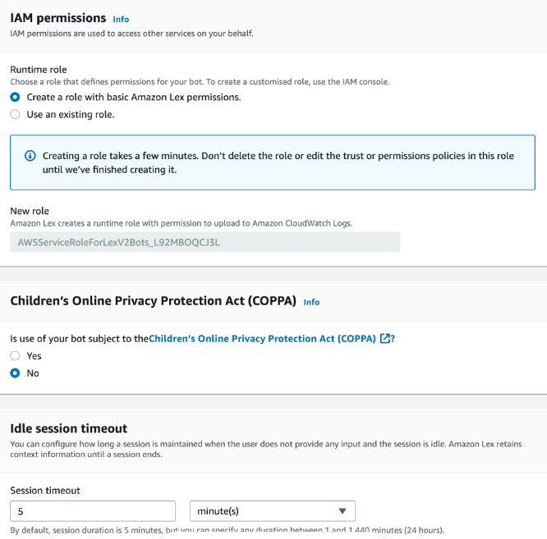

STEP 1#
- Choose a voice for your bot.
- Intent classification confidence score threshold: 0.40

STEP 2#
Create your first intent
- When your bot is created, you will automatically see a page called Intent: Book Hotel.
- Add the following user inputs (called utterances) that will trigger this intent, and paste it into the text window:
  - Hi
  - Hello

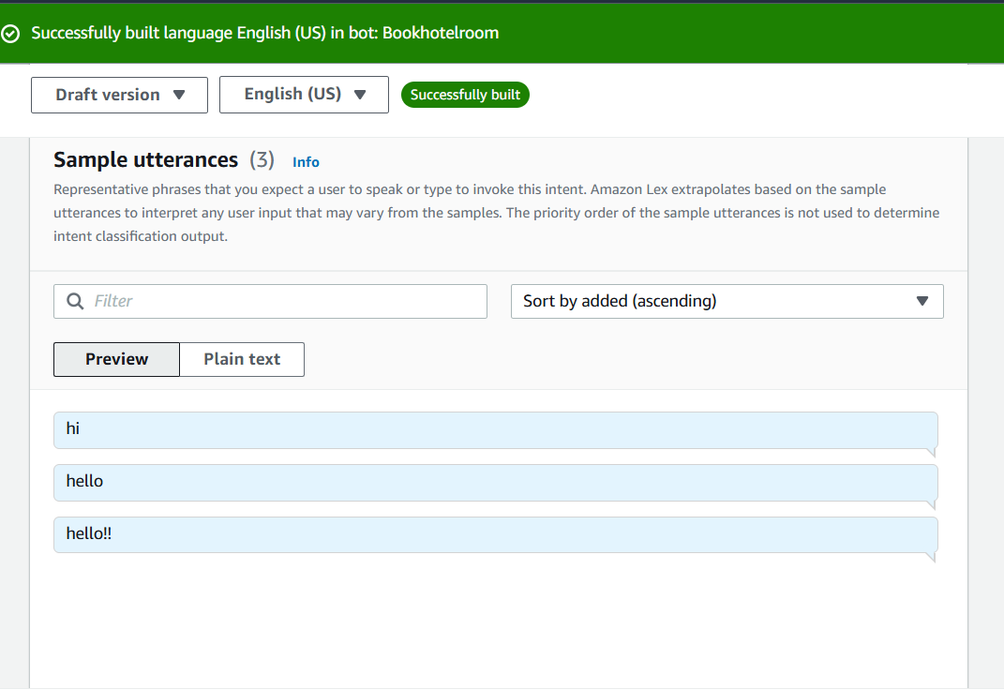

- Save the Intent till so that we can save all the configuration that we had done till now.

STEP 3#
Create your Slot types
- Go back >> To the intent list
- Slots are basically placeholder for the user input.
- Click on data type called >> add slot type >> add blank slot type
- Name the slot type name like: RoomTypes.
- Change the settings to >> Restrict the slot values.

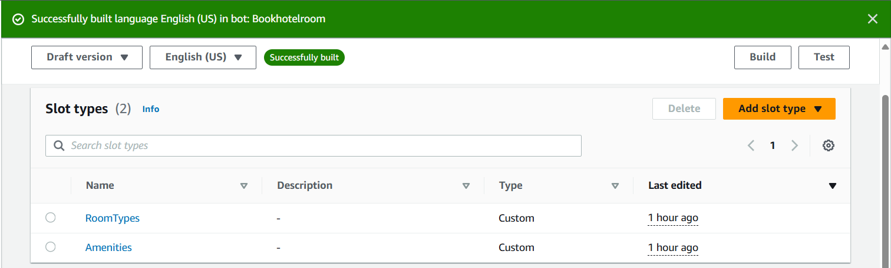

- For further configuration go back to the >>Intent

STEP 4#
Add Slots

- Click on add slot select the slot name and select the built-in slot type or user created slot type.

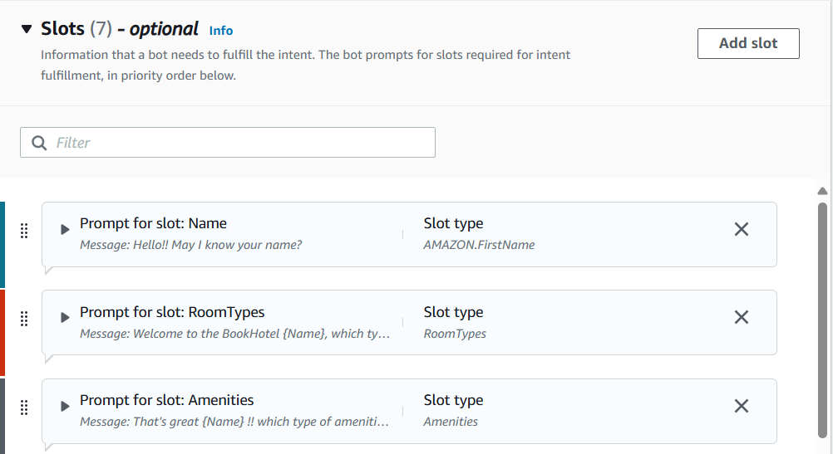
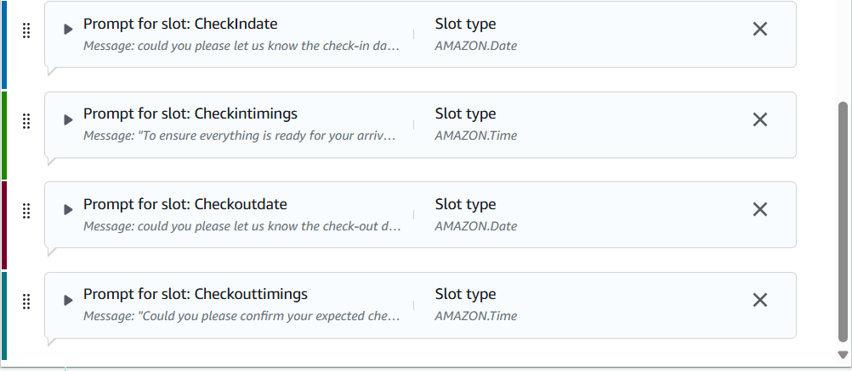

STEP 5#
Add Confirmation and decline response

- First toggle the Confirmation and decline response.
- Add the prompt for confirmation response and decline response.
- Prompt: Your order details are:
Room: {RoomTypes}.
Amenities: {Amenities}.
CheckIndate: {CheckIndate}.
Checkintimings: {Checkintimings}.
Checkoutdate:{Checkoutdate}.
Checkouttimings:{Checkouttimings}.

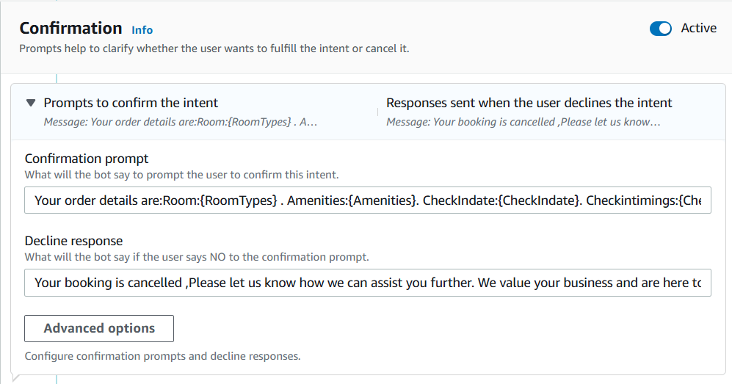

STEP 6#
Add Closing response

- First toggle the Closing response.
- Add the prompt for Closing response.
- Prompt: Thank you {Name}. Your booking is successfully confirmed.

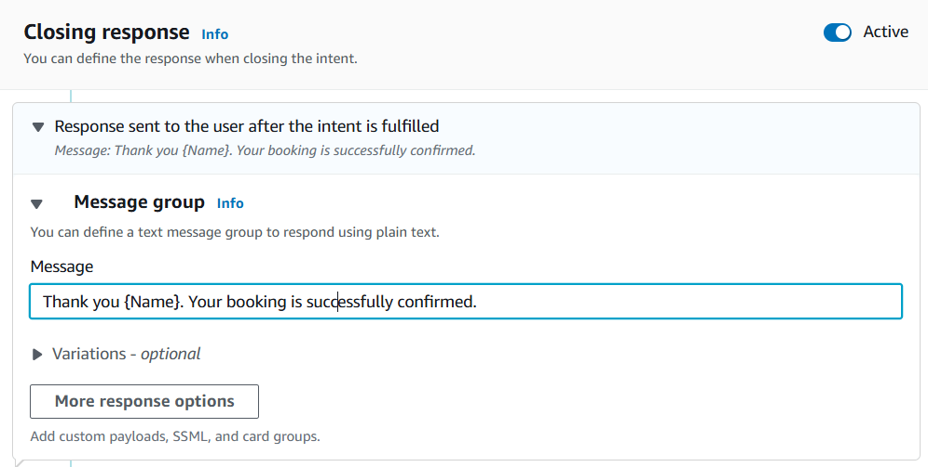

STEP 6#
Test the Conversation flow
- Save all intent build the bot and test the conversational flow.

